QUALIFICATION TEST PROCEDURE
FOR
RKVM15-5KTP2
Issue No- 1

Part No:
Doc Ref: DBPL-03-16-RKVM-08-QTP
Dated: 06/04/16
PREPARED FOR
Bharat Electronics Limited
Bangalore

PREPARED BY
DATASOL (B) PVT.LTD.
“Datasol House”, #793, 17th Cross,
Vyalikaval HBCS, (Behind BEL Corporate Office),
Veeranna Pallya, Nagawara BANGALORE – 560045

Document Number : DBPL-03-16-RKVM-08-QTP  Issue No: 01 Rev no: A  Date: 06/04/2016  No. of Pages:  Copy Number: 01 |   Datasol (B) Pvt. Ltd.
QUALIFICATION TEST PROCEDURE
For
RKVM15-5KTP2

Customer: BEL
Prepared By: | Srinivas K.
Checked By: | Mr. Rajmohan
Approved By: | Mr. Jairam Udupa
Verified and Proposed By (BEL):
Approved By :
Description: This document contains QTP for RKVM15-5KTP2.
DATASOL (B) PVT.LTD.
“Datasol House”, #793, 17th Cross,
Vyalikaval HBCS, (Behind BEL Corporate Office),
Veeranna Pallya, Nagawara BANGALORE - 560045

Document Copy No:

Copy No. | Distributed To
01
02
03 | End User (BEL)
04 | Datasol (B) Pvt. Ltd.

Record of Revisions:

SL NO | ISSUE NO | DATE | SECTION CHANGED | DETAILS OF REVISIONS | CHANGED BY DATASOL
1 | 0.0 |  | ---- | ---- | ------

TABLE OF CONTENTS
1.0 INTRODUCTION | 5
1.1 BRIEF DESCRIPTION OF RUGGED KVM | 5
1.2 FUNCTIONAL BLOCK DIAGRAM OF DISPLAY | 5
1.3 PHYSICAL BLOCK DIAGRAM OF KVM | 6
2.0 SPECIFICATIONS | 9
2.1 TECHNICAL SPECIFICATIONS | 9
2.2 POWER SUPPLY REQUIREMENTS | 9
2.3 SIZES | 9
2.4 WEIGHT | 9
3.0 TEST ACCESSORIES | 9
3.1 TEST SETUP | 10
3.2 PERFOMANCE CHECK | 11
4.0 EMI / EMC TEST SPECIFICATIONS | 12
4.1 ENVIRONMENT SPECS FOR QT: (ELECTRONIC SUB – SYSTEMS) | 13
4.2 EMI / EMC TEST RESULTS | 14
4.3 MECHANICAL DRAWING INDEX | 15
5.0 LIST OF FIGURES
FIG 1 FUNCTIONAL BLOCK DIAGRAM OF DISPLAY | 5
PHYSICAL BLOCK DIAGRAM OF RUGGED KVM
FIG 2 FRONT VIEW OF KVM | 6
FIG 3 REAR VIEW OF KVM | 6
FIG 4 ISOMETRIC VIEW OF KVM | 7
FIG 5 TOP VIEW OF KVM | 7
FIG 6 MONITOR | 8
FIG 7 FUNCTIONAL KEYBOARD / TOUCH PAD | 8
FIG 8 POWER SUPPLY | 8
FIG 9 TEST SETUP | 10
FIG 10 MECHANICAL INDEX DRAWING | 15
6.0 LIST OF TABLES
TB 1 GENERAL SPECIFICATION OF DISPLAY | 5
TB 2 TEST ACCESSORIES | 9
TB 3 PERFORMANCE CHECK | 11
TB 4 EMI / EMC TEST SPECIFICATIONS | 12
TB 5 EMI / EMC TEST RESULTS | 14
7.0 WIRING DETAILS
USB / POWER WIRING PIN DETAILS | 16
DVI CONNECTOR PIN DETAILS | 17

1.0 INTRODUCTION:

1.1. Brief Description of Rugged KVM

The KVM DSL-RKVM15-5KTP2 is providing the Human Machine Interface to the Missile Systems, it is Rugged 19” Rack mount 2U fitted with 89-key keyboard, touch pad and TFT LCD module using amorphous silicon TFT’s as an active switching devices built for space-limited environments with high graphics demand. The built-in 15.0 inch diagonally measured active area with UXGA resolutions. Each pixel is divided into RED, GREEN, BLUE dots which are arranged in vertical stripe and this display can display 262,144 colors.

1.2 Functional Block Diagram of Display.

This display applied LED backlight and a driving circuit on PCB assembly inside LCD panel.
Fig 1: Functional Block Diagram of Display

General Specification: The followings are general specifications of display.

TABLE 1: GENERAL SPECIFICATION OF DISPLAY
Parameter | Specification | Unit
Active area | 304.8 (H) X 228.6 (V) (15.0” diagonal) | mm
Number of pixels | 1600 (H) X 1200 (V) | pixels
Pixel pitch | 0.1905 (H) X 0.1905 (V) | mm
Pixel arrangement | RGB Vertical stripe
Display colors | 262, 144 | Colors
Display mode | Normally Black
Dimensional outline | 317.3 ± 0.5 (H) X 243.0 ± 0.5 (V) X 7.0 (D:max) | Mm
Weight | 510 g (typ) | g
Surface treatment | AG (H40%)2H
Back-light | Bottom edge side, LED (54ea) Backlight

1.3 Physical Block Diagram of “Rugged KVM”

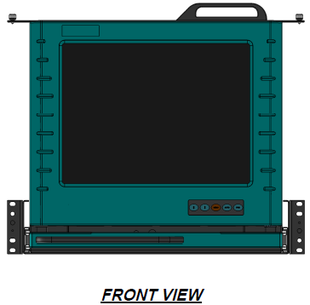
Fig: 2

Fig: 3

Fig: 4

Fig: 5

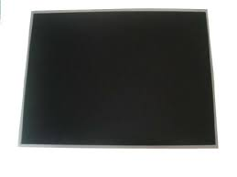
MONITOR
Fig: 6

FUNCTIONAL KEYBOARD / TOUCHPAD
Fig: 7

POWER SUPPLY
Fig: 8

2.0 SPECIFICATIONS

2.1 Technical Specifications:

- MONITOR: Anti-Glare polarizer product, wide temp liquid crystal, 2 channel LVDS interface, LED side mounting backlight, 266-144 colors, data enable signal mode, side mounting frame, green product.
- KEYBOARD / TP: 97 keys with 10-key numeric pad green backlit keys integrated touchpad. It is built into a rugged ABS polycarbonate case. It features green LED backlighting for use in low-light environments, and boasts an integrated touchpad that is designed with gloved-use in mind. Its slim features make it ideal for use on carts, wall mounts and other areas where space is at a premium.
- POWER SUPPLY: Max output wattage 75.6 & DC output 12V 6.3A.

2.2. Power Supply Requirements:

Output wattage 75.6 & DC output 12V 6.3A.

2.3. Size:

- Monitor : 317.3 ± 0.5 (H) X 243.0 ± 0.5 (W) X 7.0 (D:max).
- Functional Keyboard : 149 ± 10(H) X 379 ±.10 (W) X 12.7 (D:max).
- Power Supply : 33.528 (H) X 50.038 (W) X 150.114 (D:max).
- KVM : 16 Kgs (approx.) (Dimensions as mentioned in Mechanical drawing)

2.4. Weight:

- Monitor : 510 g (typ.)
- Functional Keyboard : 1.2 lbs (0.64 kg)
- Power Supply : 230g max.

3.0 Test Accessories.

TABLE 2: TEST ACCESSORIES
SL No | Instrument Title | Model Number | Qty
1 | KVM | DSL-RKVM15-5KTP2 | 1
2 | Rugged Workstation | Westek Rugged Chassis | 1
3 | Power cable with circular connector | MS 3470-L12-3PN | 1
4 | DVI circular connector for display | D38999 20FE 26SN | 1
5 | USB circular connector for USB port | USB FTV 21N | 1

Note: 1. Any equivalents can be used.
2. Mating connectors for KVM supplied along with it.

3.1 TEST SETUP
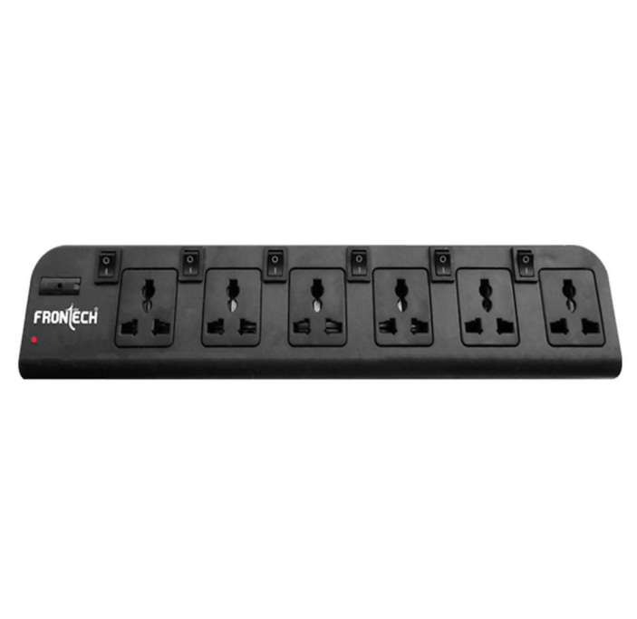
Fig: 9 TEST SETUP

For testing KVM display switch on the KVM & Westek system, the system boots showing the display on the KVM screen. Check the resolution it should be up to 1600 X 1200. Also open any application & type “When I went to school we had to write... The quick brown fox jumps over the lazy dog” (It contains all letters of the alphabet) to test the functionality of Keyboard. Use the left & right keys to see the functionallity of touchpad .

3.2 Performance Check:

TABLE 3: PERFORMANCE CHECK

STEP | TEST | REQUIREMENT | RESULT
I | PHYSICAL INSPECTION
1 | Check the KVM for any damages | No damages | OK / NOT OK
2 | Check the power circular connector properly matted at the KVM end and also clearly inserted at the power socket. | Proper fitment | OK / NOT OK
3 | Check all the connectors power & signal | No loose pins / wires | OK / NOT OK
II | FUNCTIONAL TEST:
1 | Power On Self Test:
1 | Fuctionality of KVM:  After switching ON the power to KVM & Westek system check the system got booted and display seen on the screen of KVM. | Observe:  Resolution up to 1600 X 1200
2 | Functionality of Keyboard / Touchpad:  After switching ON the power to KVM & Westek system check the system gets booted and display seen on the screen of KVM. Check the functionality of the keyboard by typing & Mouse by right clicking / scrolling. | Test by pressing the keys at keyboad & check the same is display on the screen at KVM.  Right click on mouse & also by moving cursor to check the mouse is working fine.

After checking the entire functions as shown above, shutdown the system.

TABLE 4: EMI / EMC TEST SPECIFICATIONS
DETAILED EMI / EMC TEST SPECIFICATION AS PER MIL STD- 461E
Sl No | TEST | TEST DESCRIPTION |  |  | Remarks
1 | CE102 | Conducted Emissions, Power Leads. 10 KHZ to 10 MHZ
2 | CE106 | Conducted Emissions, Antenna Terminal. 10 KHZ to 40 GHZ
3 | CE101 | Conducted susceptibility, power leads. 30 HZ to 150 KHZ
4 | CS103 | Conducted susceptibility, Antenna port. Intermodulation.15 KHZ to 10 GHZ
5 | CS104 | Conducted susceptibility, Antenna port. Rejection of undesired signals. 30 HZ to 20 GHZ
6 | CS105 | Conducted susceptibility, Antenna port. Cross Modulation. 30 HZ to 20GHZ
7 | CS114 | Conducted susceptibility, bulk cable injection. 10 KHZ to 200 MHZ
8 | CS115 | Conducted susceptibility, bulk cable injection. Impulse Excitation
9 | CS116 | Conducted susceptibility, damped sinusoidal transients.  Cables and power leads.10 KHZ to 100 MHZ
10 | RE102 | Radiated Emission, Electric field. 2 MHZ to 18 GHZ
11 | RE103 | Radiated Emission, Antenna Spurious and Harmonic outputs.  10 KHZ to 40 GHZ
12 | RS101 | Radiated susceptibility, magnetic field.30 HZ to 100 KHZ
13 | RS103 | Radiated susceptibility, Electric Field. 2 MHZ to 18 GHZ
TEST SPECIFICATION done as per JSS 55555 Equivalent to wheeled vehicles
1 | BUMP |  |  | Done with carry case
2 | SHOCK |  |  | Done with carry case
3 | VIBRATION |  |  | Done non-operational with closed display
4 | THERMAL
 | Operating temperature |  | -10˚C to +55˚C
 | Storage temperature |  | -20˚C to +70˚ C
 | Dump Heat |  | +40˚C ± 2˚C RH MIN 95%
 | Operating Altitude |  | Temp +10˚C Altitude 1.0KM
Note : Bump & Shock tests should not be done direltly on the unit. It should be done with proper carry cassing with proper packing arrangements. Design to meet JSS 55555 / equivalent for wheeled vehicles.

ENVIRONMENT SPECS FOR QT: (ELECTRONIC SUB – SYSTEMS)
(Equipment under ON Condition during the operational tests)
Sl No | Test | Test Condition | Remarks
 | Endurance test | 48 hours operation at ambient temperature. | PC to be done after every 12 hrs.
 | Random vibration  (sub – system module level) | For hard mount items: 20-50Hz PSD of 0.02 g² /HZ falling to 0.001g² /HZ at 500HZ.  For shock mounted item: 20-50 HZ falling to 0.0001 g² /HZ at 500HZ.  Duration: 15 min/axis.  Total of 45 min in all three axes. | PREET – INSET –POET tests.  Test at sub system /cabinet level.
 | High temperature  a)Operational  b)Storage  (PREET & POET Only) | 55⁰C ; 3⁰C 8 Hours  -70⁰C ± 3⁰C 8 Hours | PREET – INSET –POET tests.  PC during last ½ hour.  Visual exam and PC after recovery.
 | Damp Heat Operating | +44⁰ C ±2⁰C  RH = Min 95%; 8 Hours | PREET – INSET –POET tests.  PC during last ½ hour.  Visual exam and PC after recovery.
 | Low Temperature  a)Operational  b)Storage  (PREET & POET Only) | -10⁰ C ± 3⁰ C 8 Hours  -20⁰C ± 3⁰C 8 Hours | PREET – INSET –POET tests.  PC during last ½ hour.  Visual exam and PC after recovery.
 | Altitude Operational  (sub – system/ module level) | Temp -20⁰ c, Altitude 1.0Kms.  8 Hour duration | PREET – INSET –POET tests.  PC during last ½ hour.  PC after recovery.
 | Thermal Shock  (sub – system/module level) | +55⁰C ± 3⁰C.for 1 hr  -20⁰C ± 3⁰C for 1 hr  Humidity < 30%  Transfer < 6 min, 3 cycles | PREET – INSET –POET tests.  PC before and after the test : visual examination after the test.
 | Bump  (sub – system/module level) | Peak acceleration : 250m/s2 ± 10%  Pulse duration: 6ms ½ sine pulse  Frequency : 2-3 bumps/sec  No of bumps: 4000 | PREET – INSET –POET tests.  : visual examination and PC after the test.
 | Driving Rain Test (for exposed sub - systems only) | Rain fall rate : 250mm/hr  Flow rate : 450 lit/hr  Static pressure : 200 kPa  Duration : 1 Hr | PREET -POET tests.  visual examination and PC before & after the test.

4.1 EMI / EMC Test Results

Measurement reports for all EMI / EMC tests can be taken from lab for reference and only pass or fail needs to be filled in test data sheet below.

Indicate Pass / Fail or NA (Not Applicable) for each column.

TABLE 5: EMI / EMC RESULTS

SL No | Tests | DVI / KEYBOARD / TP
1
2

TEST DATA SHEET as per JSS 55555 DATE:

Unit SL No:

Indicate Pass / Fail or NA (Not Applicable) for each column.

SL No | Tests | DVI / KEYBOARD / TP
1
2
3
4
5
6
7

…………………………… …………………………….. ………………………………………..
Rep. BEL Rep. Datasol Lab supervisor. BEL

4.2 KVM MECHANICAL DRAWING INDEX.
Fig 10: Mechanical Drawing

7.0 WIRING DETAILS

USB CONNECTOR

connector | Pin No | Signal Description
USB FTV 21N | 1 | USB POWER Vcc
USB FTV 21N | 2 | DATA -
USB FTV 21N | 3 | DATA +
USB FTV 21N | 4 | GROUND

POWER CONNECTOR

connector | Pin No | Signal Description
MS3102R10SL-3P | A | LINE
MS3102R10SL-3P | B | NEUTRAL
MS3102R10SL-3P | C | EARTH

DVI CONNECTOR

CIRCULAR CONNECTOR PIN NO D38999 20FE 26SN | DVI-D Pin No | Signal Description
1 | 1 | TMDS Data2-
2 | 2 | TMDS Data2+
3 | 3 | TMDS Data 2/4 Shield
4 | 4 | TMDS Data4-
5 | 5 | TMDS Data4+
6 | 6 | DDC-Clock (SCL)
7 | 7 | DDC Data (SDA)
8 (NC) | 8 (NC) | Analog Vertical Sync (NC)
9 | 9 | TMDS Data1-
10 | 10 | TMDS Data1+
11 | 11 | TMDS Data1/3 Shield
12 | 12 | TMDS Data3-
13 | 13 | TMDS Data3+
14 | 14 | +5V Power
15 | 15 | Ground (for +5V)
16 | 16 | Hot Plug Detect
17 | 17 | TMDS Data0-
18 | 18 | TMDS Data0+
19 | 19 | TMDS Data 0/5 Shield
20 | 20 | TMDS Data5-
21 | 21 | TMDS Data5+
22 | 22 | TMDS Clock Shield
23 | 23 | TMDS Clock +
24 | 24 | TMDS Clock -
25 | 25 | NC
26 | 26 | C5 (GND)

